Factory Warranty:
Progressive Screens, the manufacturer of MagnaTrack and Defender Hurricane systems guarantees the material and workmanship of its products to be of excellent quality. All Materials are carefully selected to withstand most weather elements and breakage under normal use. The warranty does not cover claims originated from faulty installations, hail, flood, fire, harmful chemicals and fumes, misuse, abuse, fading, chalking, oxidization, erosion of paint, acts of God, or causes beyond control of the manufacturer. This warranty is for the benefit of the original purchaser and is not transferable. The lifetime material warranty applies to aluminum components only (prorated after 2 years).

5 YEAR WARRANTY

Progressive Screens warrants the electrical motors for a period of 5 years, commencing from the date of sale from Progressive Screen Systems, against failure under expected normal use. Warranty is void if the electrical motor is exposed to water, acts of God, or abnormal conditions, including faulty installation.

2 YEAR WARRANTY

Progressive Screens warrants the electronic components such as radio transmitters and receivers for a period of 2 year, commencing from the date of sale from Progressive Screens against failure under expected normal use. Warranty is void if the electronic component is exposed to water, acts of God, or abnormal conditions.

Screen & Vinyl Warranty

Progressive Screens warrants fabrics supplied from Twitchell have a 10-year limited warranty from the original date of purchase. The warranty covers defects of workmanship, materials, or excessive loss of strength in normal conditions, including sunlight, rot, mildew, or atmospheric chemicals that might render it unserviceable. Improper use, abuse, or use of harsh chemicals will void warranty. Fabrics not manufactured by Twitchell might have different warranties associated. Please see catalog or website for full details and warranty info.

Progressive Screens warrants our clear vinyl windows for (1) year. The warranty specifically covers manufactures defects in the material or workmanship of stitching or welding of the vinyl windows to the surrounding material. Any defects in the Vinyl panels needs to be noted upon installation of the motorized system. Discoloring, yellowing, orange-peel, or scratches discovered in the material after the install is complete is not covered and typically caused by use of improper cleaning solutions. Please see catalog or website for cleaning instructions, care and maintenance

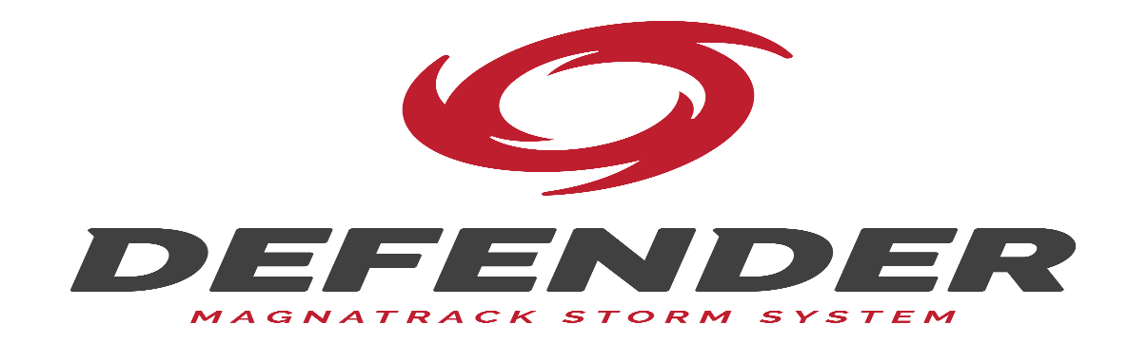

OmegaTex™ Warranty: Hurricane Screen

Twitchell Corporation produces durable, all weather fabrics that are unmatched for quality and durability. OmegaTex™ brand fabrics are covered by a 10 year limited warranty from the original date of purchase against defects of workmanship and materials, and/or excessive loss of strength from normal exposure conditions, including sunlight , rot, mildew, or atmospheric chemicals that might render it unserviceable. This warranty is extended only to the original purchaser of the material.
if the product has been subject to damage, neglect, unreasonable or improper use or care, exposure to corrosive chemicals, accidents, vandalism, acts of God, Hurricane damage, or other causes not arising from defects in original material or workmanship, this warranty is void. Twitchell does not endorse or certify end uses and customers must test the fabrics for their specific applications.
In the unlikely event that the fabric should fail during the warranty period, Progressive will repair or replace the fabric at Progressive’s discretion. A copy of the original purchase order must accompany all warranty claims.
Any defects found in regard to fabric construction, color, strength, or dimension that exist at the time of delivery must be reported to Progressive Screens within 2 weeks of receiving the product.
**Minor flaws or imperfections in the material are considered withing manufactures standards and cannot be returned or replaced. Any issues with flaws must be presented to Progressive Screens with appropriate documentation and pictures for evaluation. Progressive Screens will do our best to provide the best quality control on this process, but It is possible one or more screens of any order might have minor flaws. This system and material are first and foremost a protective device for you home or business.
Proper care includes regular cleaning. We recommend cleaning your fabric at least twice annually for residential applications and more often for high traffic areas or contract applications.

